SUSTAINABLE DEVELOPMENT GOALS
QUALITY EDUCATION (GOAL 4)
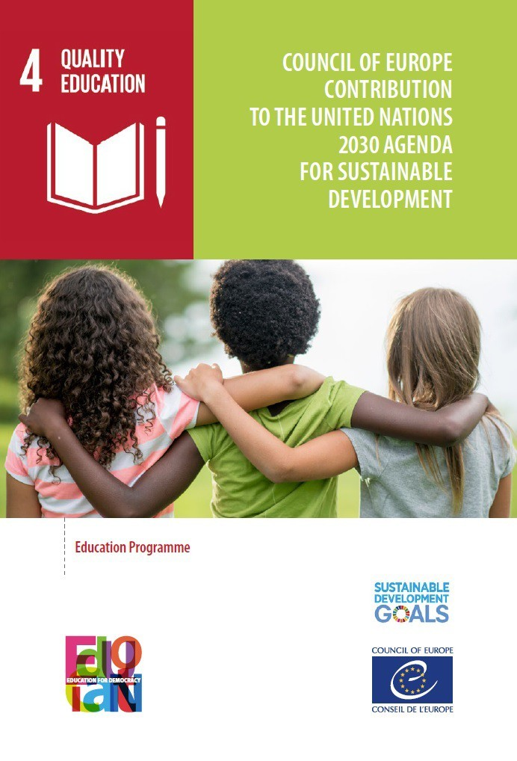
Quality education is the 4th goal of the 2030 Agenda for Sustainable Development, adopted by all United Nations Member States in 2015. Agenda 2030 for sustainable development focuses attention on lifelong learning opportunities for all. The new targets expand on their predecessors, the Millennial Development Goals, by both widening and deepening the scope of system-wide quality education systems.

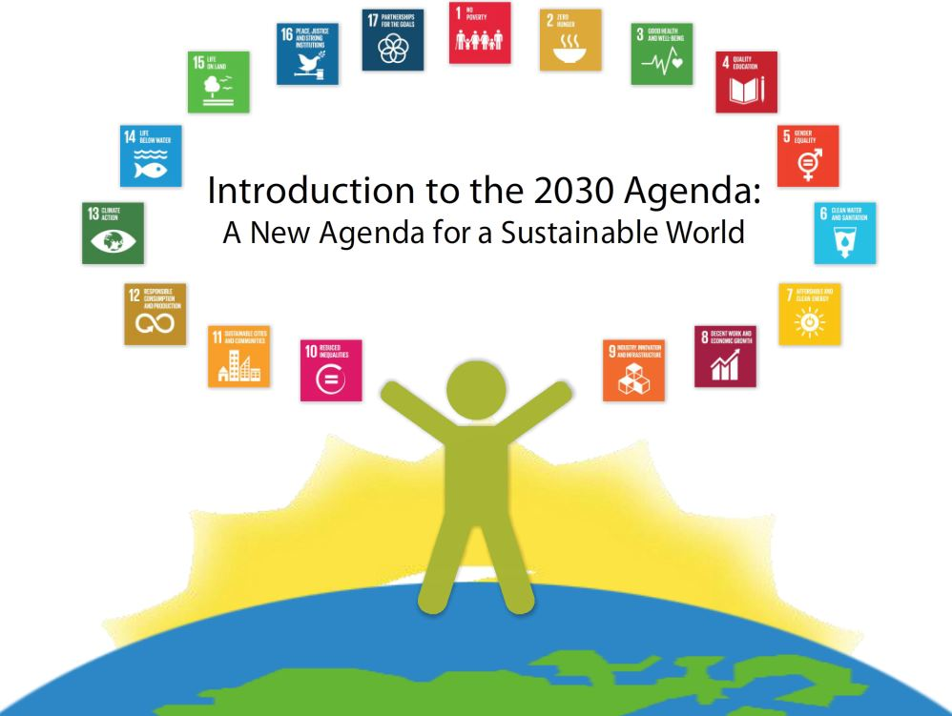

WHAT’S THE FOCUS
Goal 4 on education is made up of 10 targets. Target 4.3 introduces technical, vocational, tertiary and adult education into the global development agenda, stating ‘By 2030, ensure equal access for all women and men to affordable and quality technical, vocational and tertiary education, including university’.
There are also two other targets that deal with some aspects of higher education delivery. Target 4.b calls for more study abroad scholarships for students from developing countries and target 4.7 challenges schools and universities to build in key sustainability concepts across the curriculum, such as climate change, human rights and peace studies. After a long wait, higher education is finally formally at the development table.
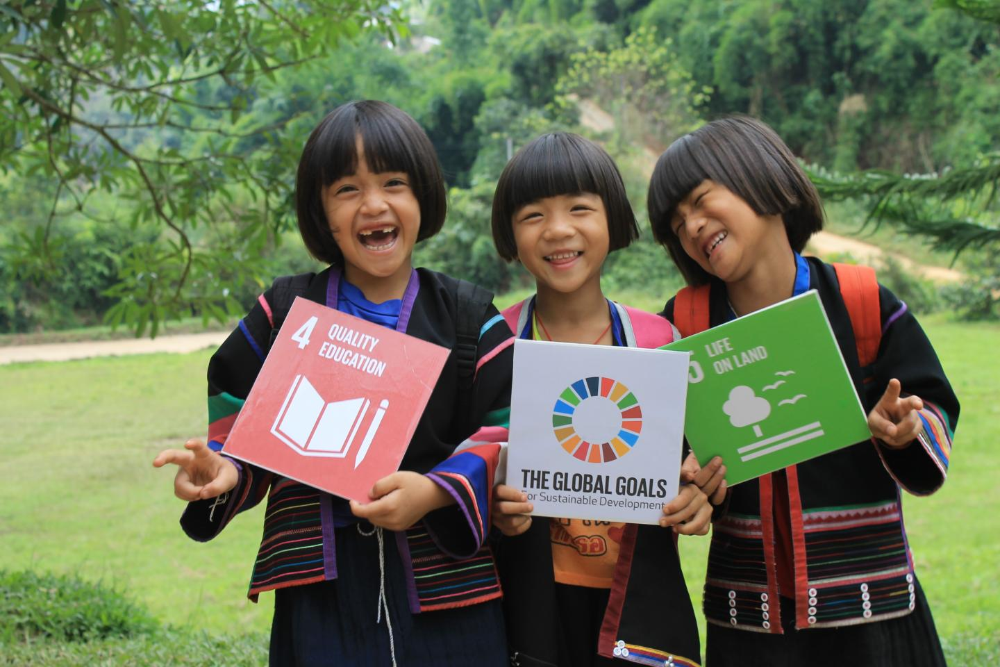

WHY THIS GOAL IS MY FAVORITE
Higher education has an important role to play in meeting the sustainable development challenges. I think attaining a certain degree in education becomes the foundation in understanding the rest of the goals. Being educated makes one knowledgeable in many things. Everyone has the right to education and when the opportunity is made available to all, it decreases illiteracy.
Quality education helps you boost your confidence throughout your life. It helps us in our personal growth and improves our career choices. Being educated means living a healthy life, eating nutritious meals, drinking potable water, taking care of one’s self generally and knowing of the dangers of the environment when not taken care of well.
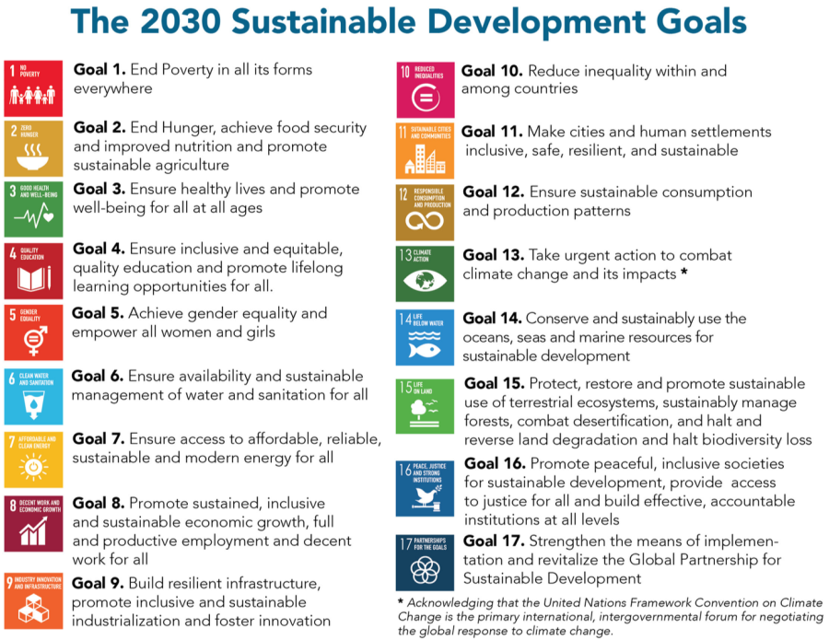
Gender inequality has a root cause in education. When one is not educated, it is easy to be discriminated again. Imagine being a girl or woman not educated, it means the chance of being unemployed is high, unemployment means not healthy because you cannot afford a three square meal which leads to malnutrition, therefore your right to enjoy the human rights fully will be undermined and your place in the society cannot be determined.
Education and quality education for that matter is the foundation for any status achieved in the society. It eradicates poverty because it means being employed and earning a remuneration. The aim of the United Nations to see to it that everybody achieves quality education will go a long way to make other goals very attainable.
It is the responsibility of each and everybody to make good use of this opportunity and all state parties must put in every effort to make this a reality. It is expensive to argue with illiterate and so, it is our duty to encourage people to get educated and cease scholarship opportunities when they present themselves.
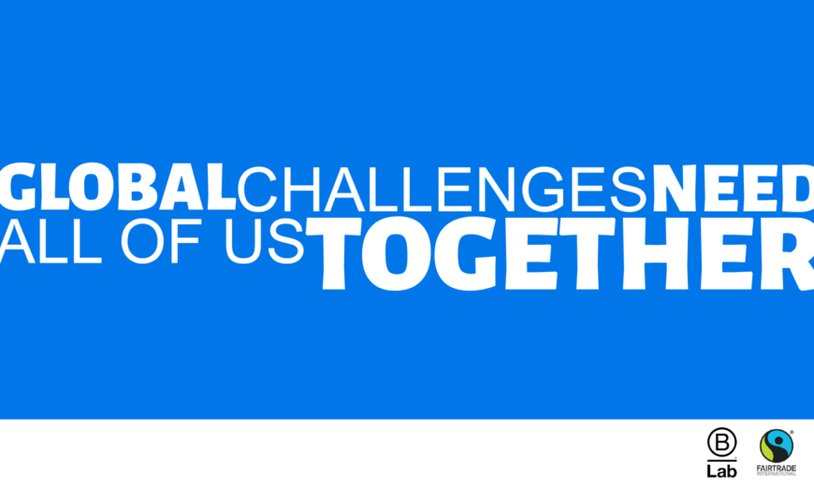
ASAMOAH ROSEMARY ACHIAA
SHANGHAI UNIVERSITY
GLOBAL STUDIES
PHD CANDIDATE

